**AWS CLI**

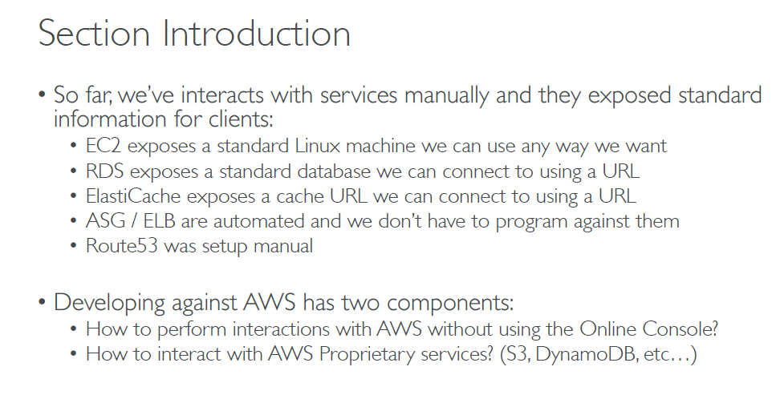

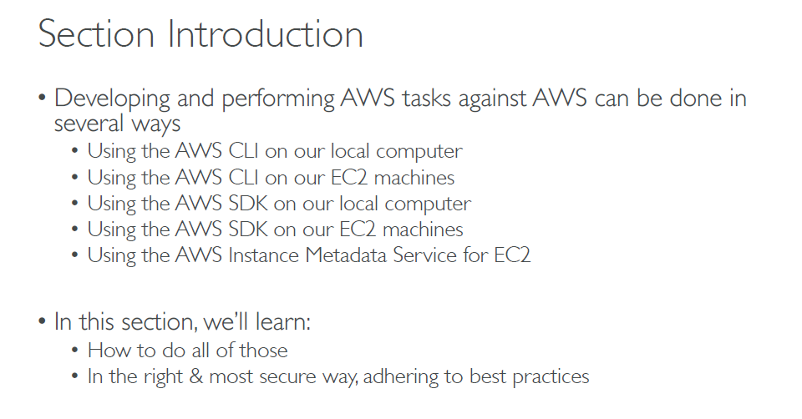

**Installing the AWS CLI version 2 on Windows**

* Download the AWS CLI MSI installer for Windows (64-bit) at<https://awscli.amazonaws.com/AWSCLIV2.msi>.
* Run the downloaded MSI installer and follow the on-screen instructions. By default, the AWS CLI installs to C:\Program Files\Amazon\AWSCLIV2.
* Verification: open cmd **C:\> aws –version**

**Uninstall the AWS CLI version 2 from Windows**

* Open **Programs and Features** by doing one of the following:
  + Open the **Control Panel**, and then choose **Programs and Features**.
  + Open a command prompt, and then enter the following command.
* C:\> **appwiz.cpl**
* Select the entry named **AWS Command Line Interface**, and then choose **Uninstall** to launch the uninstaller.

# Installing the AWS CLI version 2 on Linux

* curl "https://awscli.amazonaws.com/awscli-exe-linux-x86_64.zip" -o "awscliv2.zip"
* unzip awscliv2.zip
* sudo ./aws/install

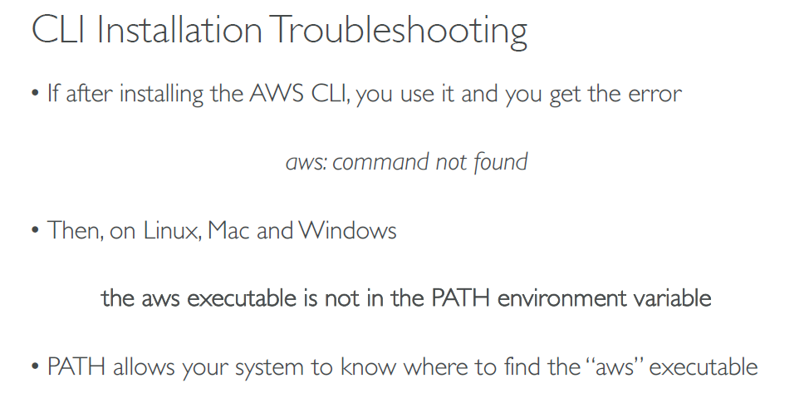

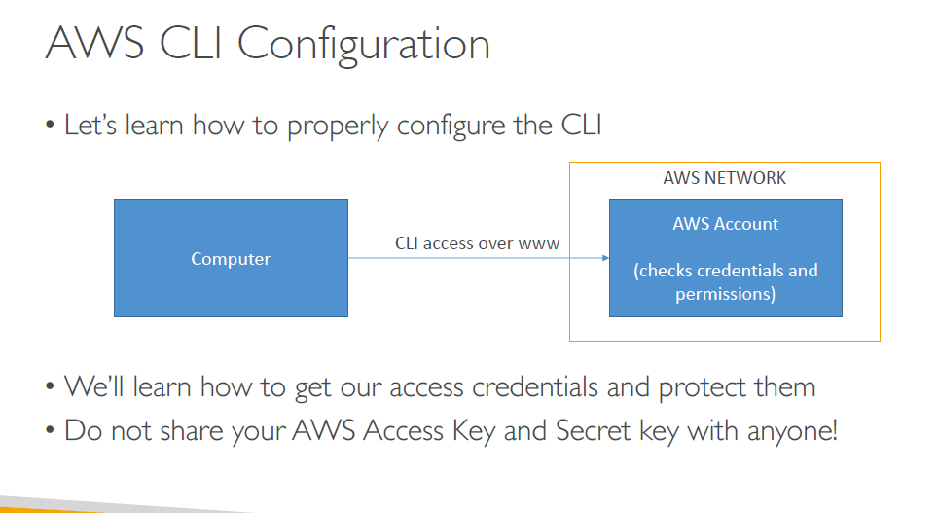

**Hands ON!!!**

* IAM select user …..security credentials….Create Access keys [access ID + secret key]
* Open cmd: aws configure
  + Provide access id with secret key

## **Set and view configuration settings**

* [aws configure list](https://docs.aws.amazon.com/cli/latest/reference/configure/list.html)

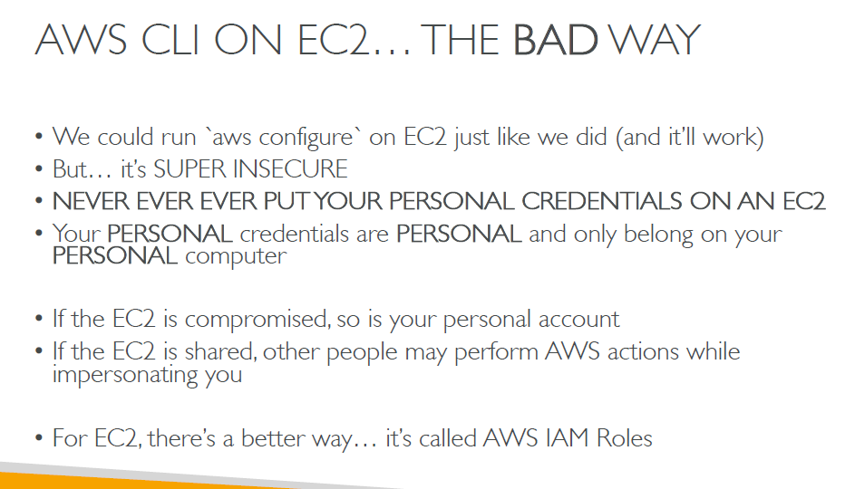

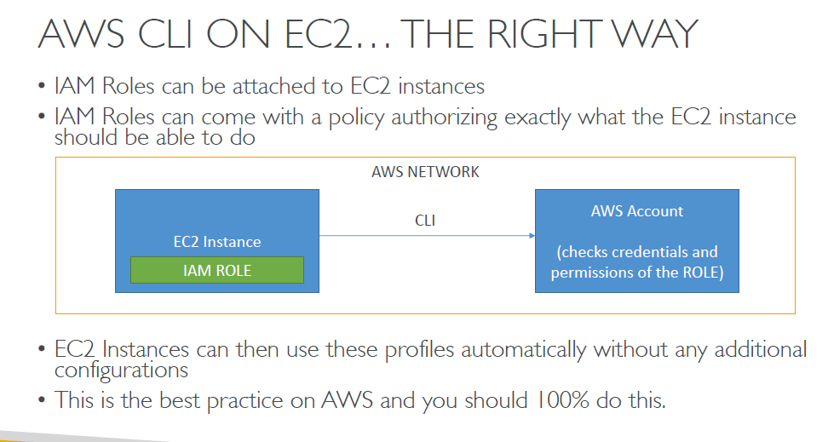

**AWC CLI CONFIGURATION IN EC2**

* Install CLI
* Open CLI: aws configure
* Acess ID: none [don’t provide just press enter]
* Secret key: none [don’d provide just press enter]
* Fill other details
* Create IAM roles to access S3 bucket & attach it to the EC2

## **AWS CLI Available Commands for S3**

* ls
* cp
* [mb](https://docs.aws.amazon.com/cli/latest/reference/s3/mb.html)
* [mv](https://docs.aws.amazon.com/cli/latest/reference/s3/mv.html)
* [presign](https://docs.aws.amazon.com/cli/latest/reference/s3/presign.html)
* [rb](https://docs.aws.amazon.com/cli/latest/reference/s3/rb.html)
* [rm](https://docs.aws.amazon.com/cli/latest/reference/s3/rm.html)
* [sync](https://docs.aws.amazon.com/cli/latest/reference/s3/sync.html)
* [website](https://docs.aws.amazon.com/cli/latest/reference/s3/website.html)

ls command

aws s3 ls

aws s3 ls s3://mybucket

aws s3 ls s3://mybucket/noExistPrefix

aws s3 ls s3://mybucket --recursive

aws s3 ls s3://mybucket --recursive --human-readable --summarize

**CP command**

* **Copying a local file to S3**
* aws s3 cp test.txt s3://mybucket/test2.txt
* **Copying a local file to S3 with an expiration date**
* aws s3 cp test.txt s3://mybucket/test2.txt --expires 2014-10-01T20:30:00Z
* **Copying a file from S3 to S3**
* aws s3 cp s3://mybucket/test.txt s3://mybucket/test2.txt
* **Copying an S3 object to a local file**
* aws s3 cp s3://mybucket/test.txt test2.txt
* **Copying an S3 object from one bucket to another**
* aws s3 cp s3://mybucket/test.txt s3://mybucket2/
* **Recursively copying S3 objects to a local directory**
* aws s3 cp s3://mybucket . –recursive
* **Recursively copying local files to S3**
* aws s3 cp myDir s3://mybucket/ --recursive --exclude "*.jpg"
* **Recursively copying S3 objects to another bucket**
* aws s3 cp s3://mybucket/ s3://mybucket2/ --recursive --exclude "another/*"
* aws s3 cp s3://mybucket/logs/ s3://mybucket2/logs/ --recursive --exclude "*" --include "*.log"

make buckets

aws s3 mb s3://mybucket

aws s3 mb s3://mybucket --region us-west-1

move commands

mv <LocalPath> <S3Uri> or <S3Uri> <LocalPath> or <S3Uri> <S3Uri>

aws s3 mv test.txt s3://mybucket/test2.txt

aws s3 mv s3://mybucket/test.txt s3://mybucket/test2.txt

aws s3 mv s3://mybucket/test.txt test2.txt

aws s3 mv s3://mybucket . --recursive

aws s3 mv myDir s3://mybucket/ --recursive --exclude "*.jpg"

aws s3 mv s3://mybucket/ s3://mybucket2/ --recursive --exclude "mybucket/another/*"

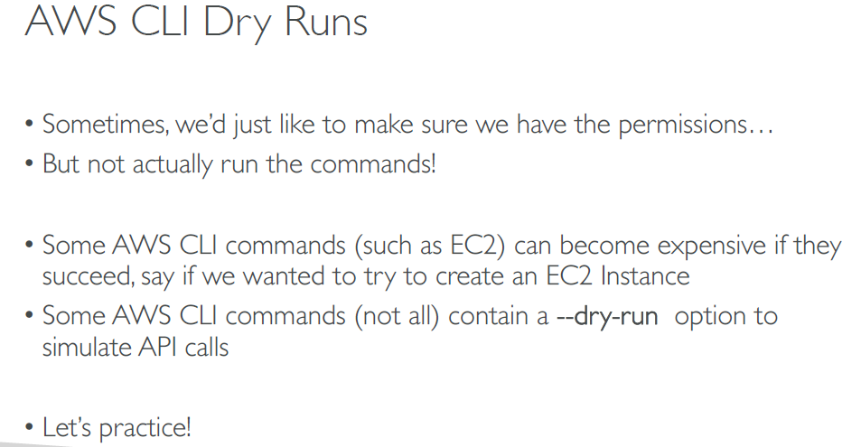

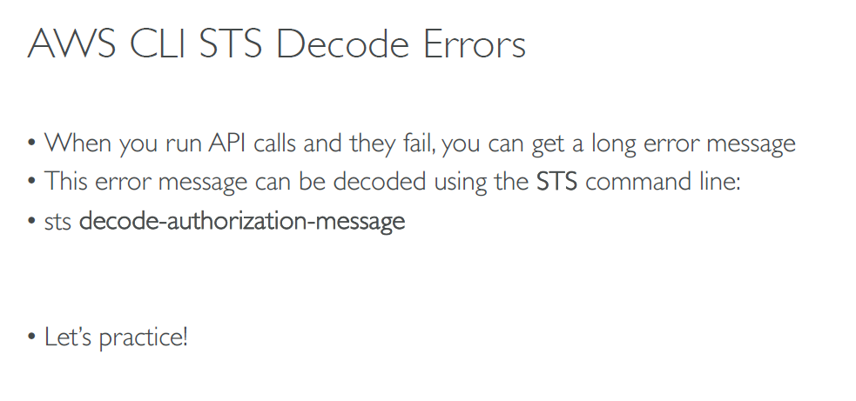

Hands ON!!

Create the policy & attach to the EC2  
 service sts with access level

aws sts decode-autorization-message –encoded-messages <paste the u got>

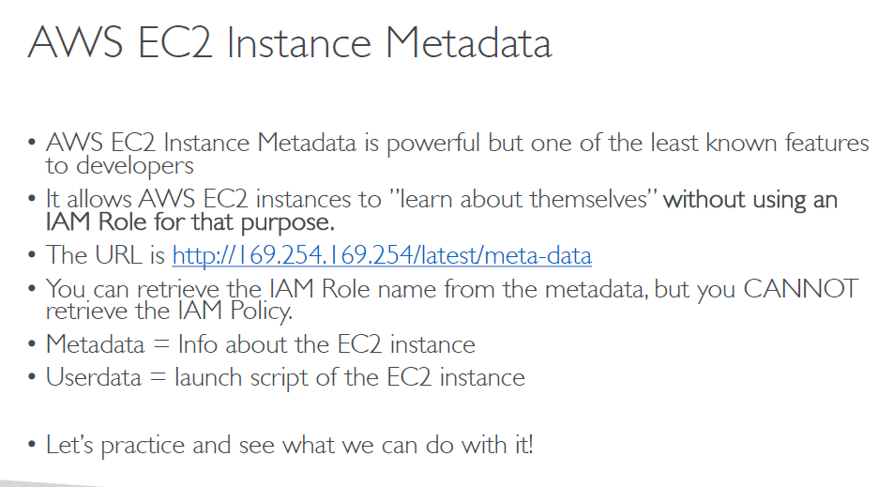

Hands On!!

It will work only on EC2

Open EC2 #curl <http://159.254.169.254/latest/meta-data/>

It list info about EC2

**AWS CLI PROFILE [how to manage multiple AWS account]**

* aws cli configure --profile <profile name>
* ID:
* KEY
* Region name:

Aws s3 ls [uses default account]

Aws s3 ls --profile <profile name>

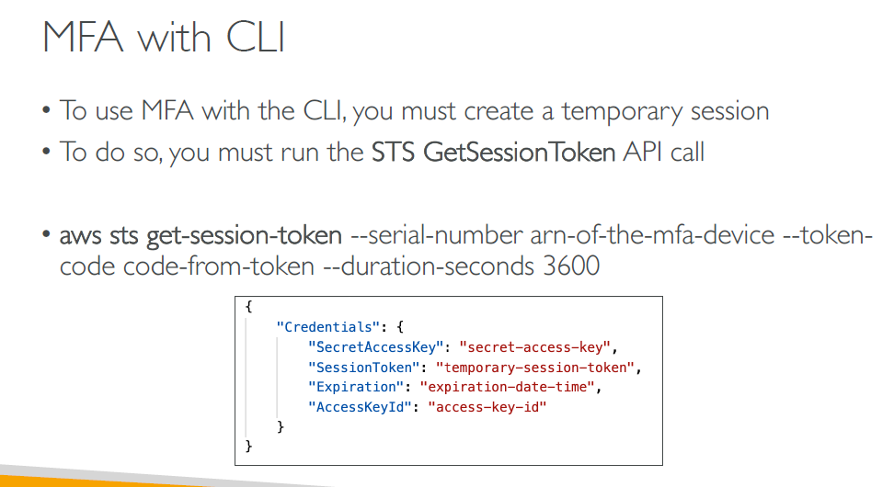

Hands ON!!

* Go to IAM USER & enable & configure MFA [virtual]
* Copy that ARN number u get
* Cli: # aws sts get-session-token –serial-number <paste arn> --token-code <enter the code>
  + You get access id secret ket session token
* Aws configure –profile mfa
* Use that id secret key
* Next vim ~/.aws/credentials
* Add aws_session_token = <paste the token>

